Hands on session

PLSQL Excerises

**Exercise 3: Stored Procedures**

Scenario 1: The bank needs to process monthly interest for all savings accounts.

* + Question: Write a stored procedure ProcessMonthlyInterest that calculates and updates the balance of all savings accounts by applying an interest rate of 1% to the current balance.

Scenario 2: The bank wants to implement a bonus scheme for employees based on their performance.

* + Question: Write a stored procedure UpdateEmployeeBonus that updates the salary of employees in a given department by adding a bonus percentage passed as a parameter.

Scenario 3: Customers should be able to transfer funds between their accounts.

* + Question: Write a stored procedure TransferFunds that transfers a specified amount from one account to another, checking that the source account has sufficient balance before making the transfer.

**Objective**

Modularize logic using stored procedures for reusability and separation of business rules.

**Steps to implement**

* Step 1: Create Tables
* savings_accounts: For interest calculation
* employees: For salary bonus updates
* accounts: For fund transfer between accounts
* Step 2: Insert Sample Data
* Add multiple records into each table for realistic testing.
* Step 3: Scenario 1 – Monthly Interest on Savings Accounts
* Use ProcessMonthlyInterest
* Step 4: Scenario 2 – Bonus for Employees
* Use UpdateEmployeeBonus(p_department_id, p_bonus_percent)
* Scenario 3 – Transfer Funds Between Accounts
* Use TransferFunds(p_from_account, p_to_account, p_amount)
* Step 6: Call Each Procedure

**Code**

SET SERVEROUTPUT ON;

BEGIN EXECUTE IMMEDIATE 'DROP TABLE savings_accounts'; EXCEPTION WHEN OTHERS THEN NULL; END;

-- Step 1: Create Tables

-- Table: Savings Accounts

CREATE TABLE savings_accounts (

account_id NUMBER PRIMARY KEY,

customer_id NUMBER,

balance NUMBER

);

-- Table: Employees

CREATE TABLE employees (

emp_id NUMBER PRIMARY KEY,

emp_name VARCHAR2(100),

salary NUMBER,

department_id NUMBER

);

-- Table: Accounts (for fund transfer)

CREATE TABLE accounts (

account_id NUMBER PRIMARY KEY,

customer_id NUMBER,

balance NUMBER

);

-- Step 2: Insert Sample Data

-- Savings Accounts

INSERT INTO savings_accounts VALUES (1, 101, 1000);

INSERT INTO savings_accounts VALUES (2, 102, 5000);

INSERT INTO savings_accounts VALUES (3, 103, 7500);

-- Employees

INSERT INTO employees VALUES (1, 'Alice', 30000, 10);

INSERT INTO employees VALUES (2, 'Bob', 35000, 10);

INSERT INTO employees VALUES (3, 'Charlie', 40000, 20);

-- Accounts

INSERT INTO accounts VALUES (101, 201, 10000);

INSERT INTO accounts VALUES (102, 202, 2000);

COMMIT;

-- Step 3: Stored Procedure - ProcessMonthlyInterest

CREATE OR REPLACE PROCEDURE ProcessMonthlyInterest IS

BEGIN

FOR acc IN (

SELECT account_id, balance FROM savings_accounts

) LOOP

UPDATE savings_accounts

SET balance = balance + (balance * 0.01)

WHERE account_id = acc.account_id;

END LOOP;

COMMIT;

END;

/

-- Call procedure

BEGIN

ProcessMonthlyInterest;

DBMS_OUTPUT.PUT_LINE('✅ Monthly interest applied.');

END;

/

-- View updated savings accounts

SELECT * FROM savings_accounts;

-- Step 4: Stored Procedure - UpdateEmployeeBonus

CREATE OR REPLACE PROCEDURE UpdateEmployeeBonus(

p_department_id IN NUMBER,

p_bonus_percent IN NUMBER

) IS

BEGIN

UPDATE employees

SET salary = salary + (salary * (p_bonus_percent / 100))

WHERE department_id = p_department_id;

COMMIT;

END;

/

-- Call procedure (e.g., 10% bonus to department 10)

BEGIN

UpdateEmployeeBonus(10, 10);

DBMS_OUTPUT.PUT_LINE('✅ Bonus updated for department 10.');

END;

/

-- View updated employee salaries

SELECT * FROM employees;

-- Step 5: Stored Procedure - TransferFunds

CREATE OR REPLACE PROCEDURE TransferFunds(

p_from_account IN NUMBER,

p_to_account IN NUMBER,

p_amount IN NUMBER

) IS

v_balance NUMBER;

BEGIN

-- Get source balance

SELECT balance INTO v_balance

FROM accounts

WHERE account_id = p_from_account;

IF v_balance >= p_amount THEN

UPDATE accounts

SET balance = balance - p_amount

WHERE account_id = p_from_account;

UPDATE accounts

SET balance = balance + p_amount

WHERE account_id = p_to_account;

COMMIT;

DBMS_OUTPUT.PUT_LINE('✅ Transfer successful.');

ELSE

RAISE_APPLICATION_ERROR(-20001, '❌ Insufficient balance in source account.');

END IF;

END;

/

-- Call procedure (valid transfer)

BEGIN

TransferFunds(101, 102, 3000);

END;

/

-- Check balances

SELECT * FROM accounts;

-- Call procedure (invalid transfer, should fail)

BEGIN

TransferFunds(102, 101, 10000);

END;

/

-- Final Output Message

SELECT '✅ Exercise 3: All procedures executed successfully!' AS status FROM dual;

**Output**

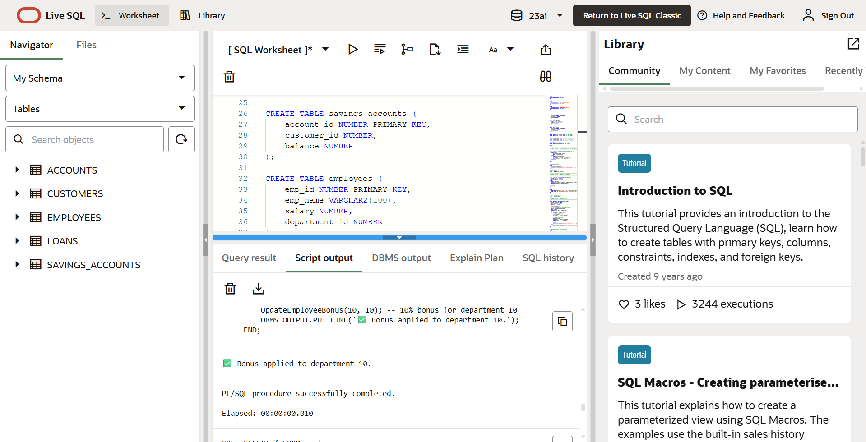

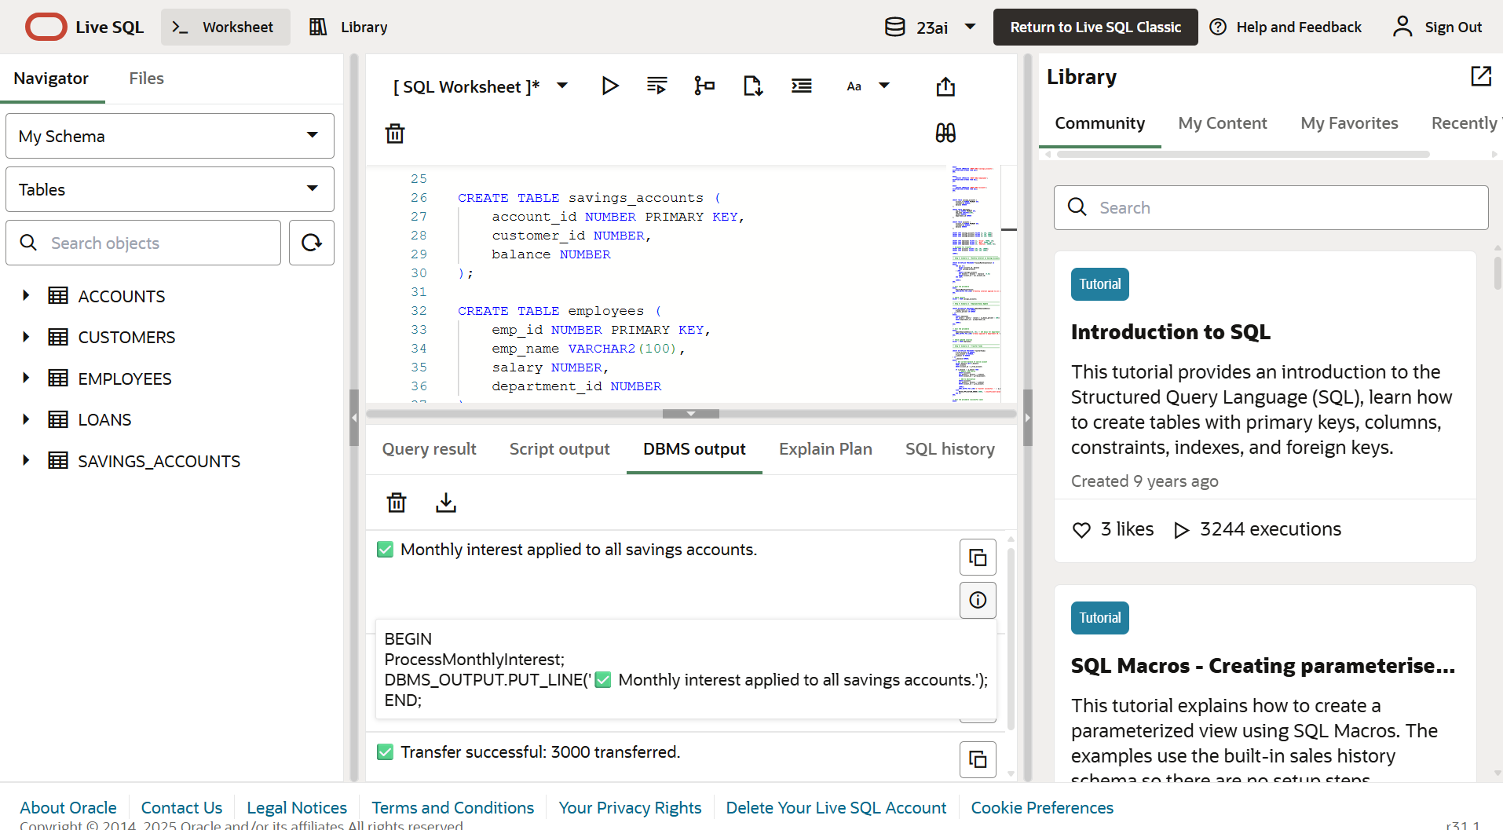

DBMS Output

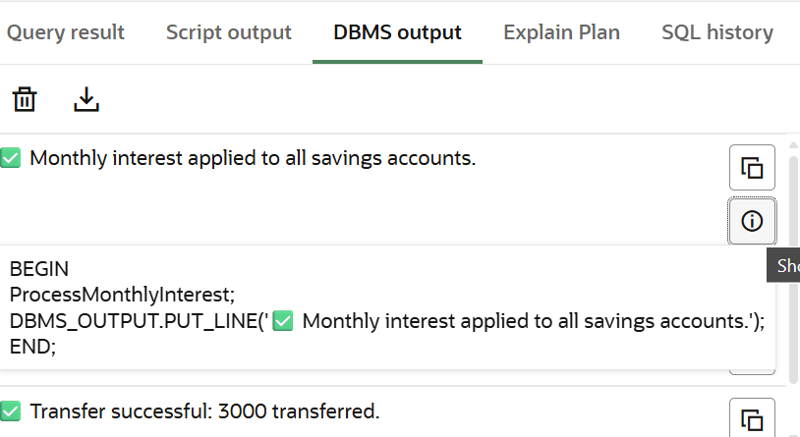

Scenario 1

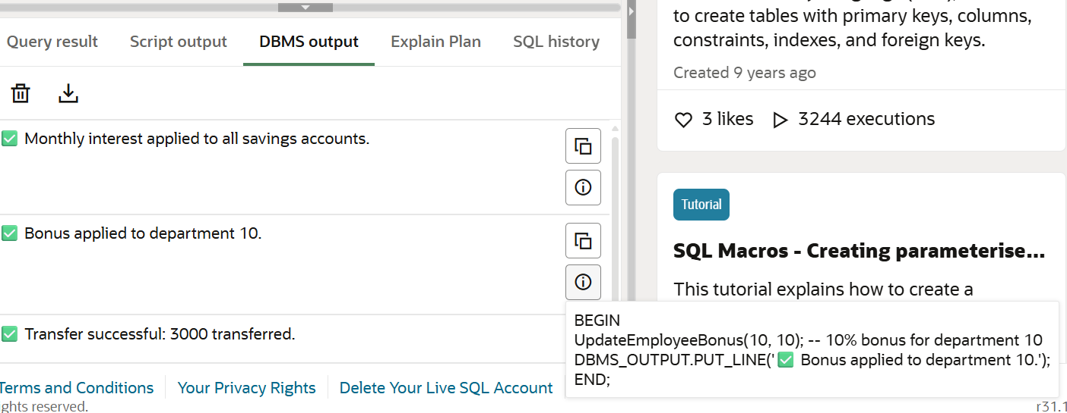

Scenario 2

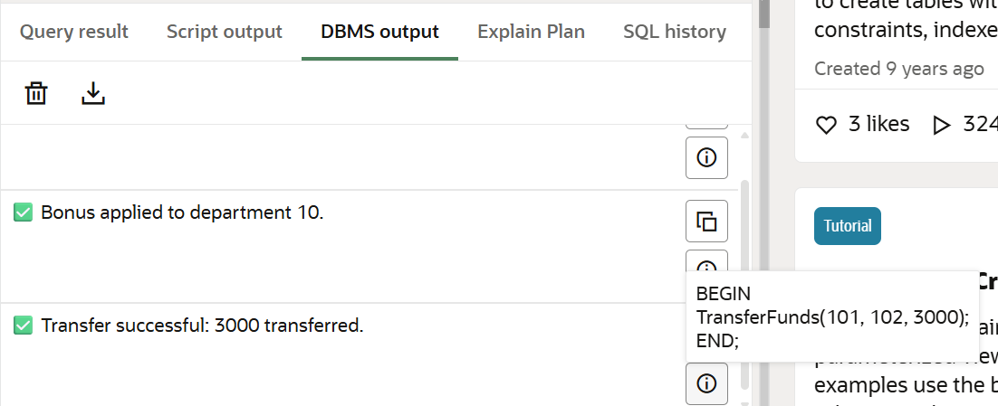

Scenario 3